**Global action on the Social Determinants of Health**

Dr. Angela J M Donkin, Prof. Sir Michael Marmot, Prof. Peter Goldblatt and Dr. Jessica Allen.

UCL Institute of Health Equity

***Abstract***

*Action on the social determinants of health is required to reduce inequities in health. This article summarises global progress. There is widespread support for a SDH approach across the world, from global political commitment to within country action. Inequities in the conditions in which people are born, live, work and age, are however driven by inequities in power, money and resources. Political, economic, and resource distribution decisions made outside the health sector need to consider health as an outcome across the social distribution as opposed to a focus solely on increasing productivity. A health in all policies approach can go some way to ensuring this consideration, and we present evidence that some countries are taking this approach, however given entrenched inequalities, there is some way to go. Measuring progress on the SDH globally will be key to future development of successful policies and implementation plans, enabling the identification and sharing of best practice. Alignment with the Sustainable Development Goals will help to forward progress measurement.*

**Introduction**

The WHO Global Commission on the Social Determinants of Health (CSDH) concluded that social injustice is killing on a grand scale. Specifically, the Commission identified inequities in the conditions in which people are born, live, work and age, driven by inequities in power, money and resources driving inequities in health. [1] As of 2014, life expectancy in Japan was 84.7 and in Chad, just 49.8years.[2] There clearly remains a rationale for action to improve the lives of those living in poorer countries such as Chad. However, as has been well documented, inequalities are also evident within countries, towns and cities, for example there is a 20 year gap in male life expectancy between the richest and poorest areas in Glasgow. The average life expectancy for men in India was sixty two at the same time that it was fifty four for men living in the poorest area of Glasgow – Calton[3]. Similarly in Baltimore and Washington DC, those living in the poor part of the city have a life expectancy twenty years shorter than those in a rich part. [4]

Inaction is not an option if we are to improve the health of populations. While there are competing views as to the scale of the influence of the SDH, Figure 1, complied by the Kings Fund, demonstrates that social and environmental influences are highly significant, contributing to between 45 and 60% of the variation in health status. Providing universal access to good health care is necessary but insufficient to optimize the health of populations and reduce inequities in health. In England for example, there is free universal health coverage but widespread, large and persistent inequalities in health between social groups.

Put simply, for many communicable and non-communicable diseases, acting at the point at which someone presents with a health problem can be too late. To improve health, reduce health inequalities and reduce costs on health care (and other service) budgets we need to improve the conditions in which people are born, live work and age.



Given persistent inequalities within and between countries and recognising the human and economic cost of inaction, the Lancet-University of Oslo Commission of Global Governance for Health called for global political solutions that go beyond the health sector alone, and beyond technical solutions and unilateral national action[5]. In this paper we develop and update our previous reporting of progress across the World, in2010, [6] and 2014.[7]

**Global action**

Following the WHO Commission on Social Determinants of Health, the Rio Political Declaration on Social Determinants of Health[8] was adopted by 125 member states during the WHO World Conference on SDH on 21 October 2011. The declaration expresses global political commitment for the implementation of a SDH approach to reduce health inequities and to achieve other global priorities. The rationale was that it would help to build momentum within countries for the development of dedicated national action plans and strategies.[9]

In 2011 the UN General Assembly also adopted the Political Declaration on the Prevention and Control of Non-communicable Diseases[10] calling for the development of multi-sectoral approaches to health at all government levels and to address the underlying determinants of health.

In May 2012 the 65th World Health Association endorsed the Rio declaration and its recommendations. It approved measures to support the five priority actions recommended in the declaration to address social determinants of health.[11] This was followed by a UN Resolution on Global Health and Foreign Policy in December 2012 calling upon member states and the UN to accelerate universal health coverage and implement broad public health measures addressing the SDH through cross-sectoral policies.[12]

The 2010 WHO Adelaide Statement on Health in All Policies (HiAP) paved the way for global recognition of the need for cross-sectoral action as well as considering health in wider policies in order to improve health outcomes and equity. HiAP is a policy strategy which targets the key social determinants of health through integrated policy response across relevant policy areas with the ultimate goal of supporting health equity. HiAP is thus closely related to concepts such as ‘inter-sectoral action for health’, ‘healthy public policy’ and ‘whole-of-government approach’. The HiAP approach is being advocated in several countries and in June 2013 the WHO 8th Global Conference on Health Promotion was dedicated to HiAP[13], building momentum for its implementation and highlighting the need to strengthen skill and political capacity to address the SDH.

There have also been a number of recent and significant supporting global developments, with perhaps the most significant recent social policy development being the adoption of the Sustainable Development Goals (SDGs) by the United Nations (UN)[14]. The adoption of the SDGs represents a change from the Millenium Development Goals because of the high level of commonality between the SDGs and the improvement of the SDH[15]

Another important development is The Declaration of Oslo, agreed at World Medical Association (WMA) Council meeting in Oslo in April 2015, and passed by the General Medical Assembly in Moscow. It sets out the importance of social determinants of health and principles of action for WMA, National Medical Associations and individual doctors. [16] This declaration explicitly sets out a role for the WMA in advising doctors and other health professions of good and innovative examples that will have a positive impact on the social determinants of health. In doing so it importantly sets out an advocacy and leadership role for doctors and health professionals to improve people’s lives through action initiated outside the health sector.

The following sections provide a range of examples of progress across the World.

**Europe.**

Health 2020 is the European health policy framework adopted by the 53 Member States of the WHO European region in September 2012. It aims to support action across government and society to: “significantly improve the health and well-being of populations, reduce health inequalities, strengthen public health and ensure people-centred health systems that are universal, equitable, sustainable and of high quality”. In October 2010, WHO European Office launched a review of social determinants and the health divide in the region[17] to support the Health 2020 strategy. The report, published in 2013, contains proposals for taking action and was based on the latest research and conceptual approaches, building on global evidence and recommending policies to reduce health inequalities across all countries in the region.[18].

In 2015, the 53 member states of the region signed the Minsk agreement committing to ”the adoption of the life-course approach across the whole of government that would improve health and well-being, promote social justice, and contribute to sustainable development and inclusive growth and wealth in all countries.

The European Commission’ s (EC) ‘EU Health Strategy – Together for Health: A Strategic Approach for the EU 2008-2013’ includes reducing health inequalities as a core principle, and in 2009, the European Commission published a communication on the importance of reducing health inequity within Europe and set out a framework for action[19]. The EC encourages action on the social determinants of health, promoting healthy lifestyles and supporting access to and quality of healthcare services.

Alongside the strategy, the commission also administers the EU Health Programme Fund which is the main instrument the EC uses to implement the EU Health Strategy. This has provided an important strand in the EU contribution to reduce health inequalities in Europe by co-funding projects and actions through successive Health Programmes since 2003. To date, a total of 64 actions, involving nearly 700 organisations and institutions from all EU, EFTA and EEA countries and some candidate countries, have been funded, with EC co-funding amounting to €40 million. The current, Third Health Programme 2014–20, is geared towards contributing to the objectives of the Europe 2020 strategy, and continues to address health inequalities as a priority[20].

The European Commission summarise their actions by distinguishing actions to target vulnerable groups from those relating to gradients and gaps. Their categorisation of actions is shown in Table 1.

Table 1

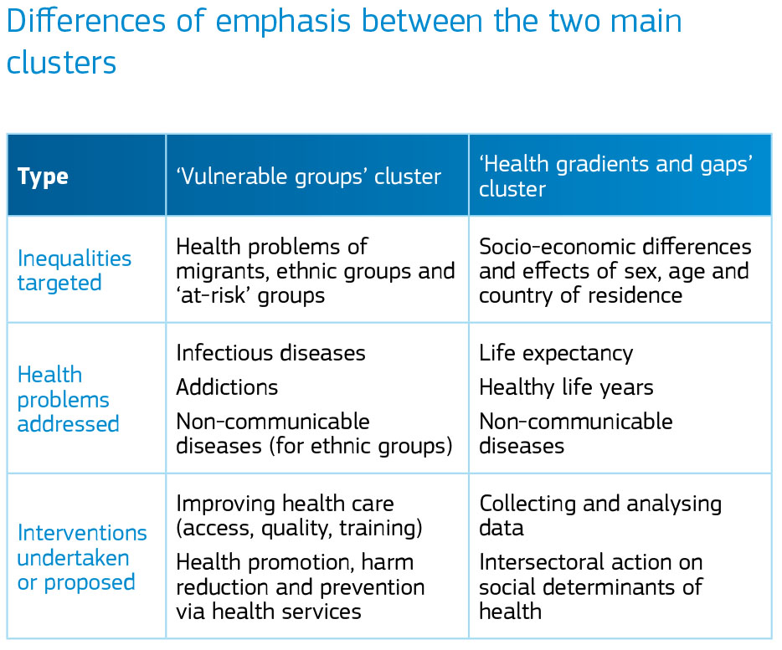

Source: CHAFEAxvii

The location of each action on these dimensions is summarised in Figure 2, with vulnerable groups further subdivided by the European Commission into two clusters – “migrants and ethnic groups” and “at-risk groups”.

**Figure 2**

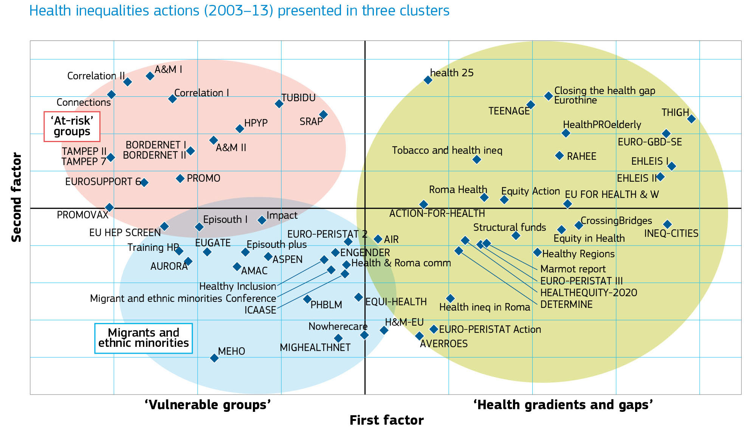

Source: CHAFEAxvii

There are a number of other EU regional policy initiatives that address social determinants, directly or indirectly as part of the EU Structural Fund. For example, the European Social Fund invests € 80 billion on:

* promoting employment and supporting labour mobility
* promoting social inclusion and combating poverty
* investing in education, skills and lifelong learning
* enhancing institutional capacity and an efficient public administration

The European Parliament has recently allocated funds to develop pilot projects designed to test the feasibility and usefulness of action in the area of health inequalities[21].

The European Pact for Mental Health and Well-being is another related EU policy initiated in 2008. It recognizes that considerable inequalities in mental health status exist and seeks to address these.

The UNDP has also been working with national partners to forward action on Social, Economic and

Environmental Determinants of Health (SEEDS) in the context of sustainable human development.

In addition they have specific work in Eastern Europe to promote inclusion of the Roma population into economic, social and civic life, as well to support and monitor the development of national Roma inclusion strategies.[22]

National activities in a number of countries have followed the publication of Health 2020 with Lithuania producing a new national health plan and Serbia running an appraisal of cross-sectoral governance systems and capacity to address social inequalities. In 2013, France launched a national health strategy. This included a social contract under which every government department would be accountable for the impact of their policies on public health and health inequalities., with the aim of ensuring a strong focus on the social determinants of health inequalities[23]. Eight member states requested support from the WHO to integrate equity in the policy process and a further six member states are working with WHO Regional Office for Europe to develop strategies to address the SDH and health equity with a particular focus on the Roma population.

Northern European countries have a longer history of attempting to tackle health inequalities, and continue to finesse the tackling the social determinants of health at a local and national level. A review by the UCL Institute of Health Equity within England in 2013 found that at least 75% of local areas had embedded SDH recommendations into their strategy documents. Sweden have recently appointed a commission on health inequalities to further inform their strategy, and Norway, Hungary and Poland have produced analytical reports. [24]

However, while many health departments have embraced the SDH rationale, they do not hold key levers for change. Social policy is often aligned with the SDH, however economic policies to promote growth may have done so at the expense of quality of work and security, austerity programmes have resulted in reduced services and cuts to the real value of social protection. More should be done to incentivise, or require, other sectors to consider health outcomes.

Some countries have considered how best to do this with a ‘Health in All Policies’ (HiAP) approach. Within the EU context the concept of HiAP was brought forward during the Finish EU Presidency in 2006, and following Finland’s adoption of the strategy. The EU treaty obliges all EU policies to adhere to the HiAP approach, although not all countries have yet integrated this into legislation. Given the current policy environment, integrating the HiAP approach with the requirement to adhere to the SDGs makes much sense. For example, in April 2016, the Welsh, ‘The Wellbeing of Future Generations’ Act came into effect. The Act requires that there is a commissioner, guidance and training material for a wide range of public bodies who will have legal obligation in a number of areas that codify the Sustainable Development Goals, including prevention. The overarching goals are to ensure Wales is: prosperous, resilient, equal, cohesive, healthy, culturally sensitive and globally responsive.

**North America**

Canada has been at the forefront of research into the SDH, and this continues to be the case, with academics and practitioners advocating an SDH approach to public health and influencing policies.

Social determinants of health are now firmly on the agenda in Canada. There is a great deal of activity both at national and provincial level. The Federal Minister of Health has declared publicly that SDH is a priority for the government. Supporting the Federal Ministry, the Public Health Agency of Canada has a Social Determinants of Health team. Several Provinces have social determinants of health as central to their plans. The Canadian Medical Association has declared their commitment to action on SDH. In pursuing this goal, they held Town Hall meetings across the nation to engage public opinion. [25] [26]

Recent policy initiatives in the U.S, created by various provisions of the 2010 Patient Protection and Affordable Care Act; Healthy People 2020; and the National Partnership for Action has created an environment for the U.S. to address social determinants of health and health equity. The Patient Protection and Affordable Care Act, established the nation’s first National Prevention Council with heads of 17 federal agencies representing multiple sectors that impact health (e.g., education, transportation, justice, etc.) The National Prevention Council developed the *National Prevention Strategy* which seeks to improve health outcomes by moving the nation from a focus on sickness and disease to one based on prevention and wellness.

In addition there are a number of delivery and payment reform initiatives within Medicaid to address the diverse needs of the population served through an increased focus on social determinants of health. For example through the  **State Innovation Models Initiative (SIM), a number of states are engaged in multi-payer delivery and payment reforms that include a focus on population health and recognize the role of social determinants. For example** Connecticut’s SIM plan seeks to promote an Advanced Medical Home model that will address the wide array of individuals’ needs, including environmental and socioeconomic factors that contribute to their ongoing health. Its plan also includes community health improvement efforts that will coordinate efforts across community organizations, providers, employers, consumers, and local public health entities.[27]

Also in 2010, the Healthy People initiative, coordinated by the U.S. Department of Health and Human Services, added social determinants of health topic area. This national initiative involves a network of governmental, private, non-profit, and academic partners who work together to set priorities for national public health improvements[28]

In 2011, the *National Partnership for Action* – the nation’s first roadmap for reducing racial and ethnic health disparities – was released by the U.S. Department of Health and Human Services. A dual approach of public health, policy and research actions directed by federal agencies to reduce health disparities coupled with broad local and regional engagement in the implementation of public health strategies to reduce disparities is underway across the US.

**The Americas**

Despite many achievements in public health and poverty reduction over the last 110 years, the Americas continues to be one of the most unequal regions in the world. For example, poverty is still widespread in South America: nearly one in five of the Region’s residents lives on less than US $2 a day[29] (Pan American Health Organization [PAHO], 2011). These socioeconomic inequalities are reflected in stark differences in health outcomes among the most deprived and excluded populations in the Region. For example, approximately 30% of all tuberculosis cases in the Americas are concentrated in the lowest quartile of human development (PAHO, 2011). The countries in the region are also at different points along the epidemiologic transition, with certain countries facing a disproportionate burden of infectious disease and maternal mortality, while others are progressively facing higher rates of non-communicable disease.

Strategies to address health inequity and inequality are increasingly at the centre of global and regional action in the Americas. In 2016 PAHO commissioned a two year independent Review to describe and analyse major drivers of health inequalities across the whole region, with particular focus on 14 partner countries. The Commission will make recommendations for action to improve equity and inequalities in health for international, national and local organisations. The recommendations and analyses will focus on social determinants, ethnicity, gender and human rights and will align with the Sustainable Development Goals.

Many countries in the Region already have a longstanding and strong focus on social medicine, health equity and human rights and HiAP. In 2006 Brazil undertook a National Commission on Social Determinants of Health[30], and in Argentina and Chile, policies and governance arrangements were created to promote social determinants in the ministries of health and at high levels of national government. In South America, the Union of South American Nations’ Council of Ministers of Health identified SDH as one of the five priorities in its 2010 -2015 Plan of Action. Mercosur created an Intergovernmental Commission on Health Promotion and Social Determinants of Health, and PAHOs Strategic Plan (2014--2019), ensured that SDH is an integral part of the Organization's five-year plan.[31] The Sustainable Development Goals are an important mechanism through which to take action on social determinants. Many countries in the Region are taking action on the social determinants and making progress in tackling health inequalities.[32] Poverty is still widespread in South America: nearly one in five of the Region’s residents lives on less than US $2 a day[33] These socioeconomic inequalities are reflected in stark differences in health outcomes among the most deprived and excluded populations in the Region. For example, approximately 30% of all tuberculosis cases in the Americas are concentrated in the lowest quartile of human development (PAHO, 2011). The countries in the region are also at different points along the epidemiologic transition, with certain countries facing a disproportionate burden of infectious disease and maternal mortality, while others are progressively facing higher rates of non-communicable disease.

Strategies to address health inequity and inequality are increasingly at the centre of global and regional action in the Americas. In 2016 PAHO commissioned a two year independent Review to describe and analyse major drivers of health inequalities across the whole region, with particular focus on 14 partner countries. The Commission will make recommendations for action to improve equity and inequalities in health for international, national and local organisations. The recommendations and analyses will focus on social determinants, ethnicity, gender and human rights and will align with the Sustainable Development Goals.

**North Africa and the Middle East**

The WHO Regional Office for the Eastern Mediterranean Region (EMRO) initiated a regional strategic direction to implement the Rio political declaration, which was agreed by representatives of member states at a regional workshop in Cairo in September 2012. The regional office also supported the creation of a national database for health equity in Iran and capacity building in Afghanistan, Iraq and Oman for collecting and analysing disaggregated equity data.

The report identified a number of key themes specifically relevant to the region which interact with and impact on the SDH, in particular issues of gender equity, the status and employment conditions of migrants, fast urbanisation and conflict all tend to hinder development, improvement of the SDH and equity.

Since the Commission on the Social Determinants of Health 2005-8, a number of initiatives have taken place to improve the knowledge base in the region and to engage member countries in debate on the SDH. In particular knowledge sharing between academic institutions and non-profit organisations, and the production of country-level studies is seen as the basis for advocacy and the engagement of governments in the issue. Provision of primary health care is also seen as an entry point to raise awareness of the SDH in political debate. EMRO therefore initiated a consultation with member states on focusing community and primary care on the SDH as well as running a pilot programme of intersectoral action aimed at tackling health inequalities in a number of countries. It also runs programmes covering literacy, training and income in 12 of the 22 member states in the region (Afghanistan, Djibouti, Egypt, Iran, Iraq, Lebanon, Morocco, Oman, Pakistan, Somalia, Sudan, and Yemen); consideration is being given to ways of implementing programmes evaluated in other countries - such as conditional cash transfers to women in Latin America - in the context of different gender relations in the region. Community-based initiatives run by EMRO cover a population of around 3.7 million across all countries in the region and cover basic development needs, healthy cities and healthy villages, and women’s development.

At the 61st session of the Eastern Mediterranean Regional Committee, member states agreed a plan to hold a regional consultation on reducing health inequities in EMR through actions on the social determinants. The meeting was held in Tehran, Islamic Republic of Iran, on 21–23 April, 2015. The meeting was attended by 22 participants from 13 countries in the Region (Afghanistan, Islamic Republic of Iran, Iraq, Jordan, Kuwait, Libya, Morocco, Oman, Palestine, Pakistan, Saudi Arabia, Sudan, and Tunisia), 15 experts, and staff representing the United Nations Development Programme and WHO. Member States and WHO agreed to implement the components of a proposed framework on SDH and related actions with technical support from WHO. The first action point was to support, four countries (Islamic Republic of Iran, Jordan, Morocco, and Palestine) to conduct in-depth assessments of health inequity, the main SDH, ongoing relevant action and gaps in monitoring systems.

**Africa**

To address widening health inequities within and between countries in the WHO African Region, accelerating response to the determinants of health was identified as one of the 6 WHO Strategic Directions for achieving sustainable health development in the African Region between 2010-2015. The strategy presents several priority interventions for reducing inequities through action on social determinants of health aligned to the key recommendations of the CSDH.

In May 2013 the WHO Regional Office for Africa (AFRO) gathered stakeholders from twelve Eastern and Southern African countries to discuss how HiAP can be implemented at the national level in order to achieve health equity; AFRO is also supporting the documentation of inter-sectoral case studies in Angola, Congo and Mozambique. The 7th Global Conference on Health Promotion was held in Kenya in 2009, the first time it was held in Africa, and included presentations and discussions around the SDH.

The WHO’s Equity, Health, Health Policy and Human Development (ETR) programme works with AFRO to support member states implementing programmes addressing the SDH through the development of policies enhancing health equity, gender equity, human rights and poverty reduction. It also aims to support regions and member states to achieve greater synergy between trade and health policy to maximise benefits for poor and vulnerable populations. UCL IHE are currently engaged with DFID in Tanzania to further their understanding of the role that the social determinants of health might have on human development outcomes in rapidly growing cities.

**Asia**

The Who Regional Office for South East Asia (SEARo) have conducted reviews to assess the experience of inter-sectoral policies and actions to inform the development of further initiatives. A number of countries within the region have demonstrated promising results to improving health and addressing health equity. A review of Action to Address the Social and Environmental Determinants of Health Inequity in Asia Pacific was undertaken by Asia Pacific HealthGAEN and published in 2011. This identified a number of examples of action across the Asia Pacific region.[34]

There are a number of more recent examples. Thailand has been one of the most successful countries in reducing child mortality. Alongside improvements in equitable access to health care, Thailand holds a particularly democratic national health assembly open to the public each year, with regional representatives participating in health policy development

Bangladesh has also seen large improvements in health outcomes. Latest data for 2013 show that life expectancy at birth was 71, compared to India at 66. This success has been attributed to poverty reduction, an increase in health resources and effective community based interventions. The contribution of the Bangladesh Rehabilitation Assistance Committee (BRAC) to this success has been recognised, specifically in terms of co-ordinating the activity of NGOs.

Not all states in India fare worse than in Bangladesh, the state of Kerala stands out. In Kerala the life expectancy of women is an impressive seventy-seven. Kerala has a good track record in human development, it has high levels of education, a more communal orientation than other states and higher status for women – all of which are closely related to positive health outcomes. [35]

In India 63% of adults are literate, by contrast in Sri Lanka, 90 percent of adults are literate. India’s economic growth at 6-8% a year high relative to other parts of the world, but it is likely that the benefits of that growth would reach further if education were more widely spread and economic benefits were more equally distributed. [36]

The WHO Regional Office for the Western Pacific Region (WPRO), AP-HealthGaen and the Social Inequity Reduction Network in Thailand advocated for addressing determinants of health beyond health sectors and strengthening capacities for health equity analysis and health impact assessment. WPRO is also in the process of identifying suitable cases studies for the assessment of experiences of inter-sectoral policies and has supported Cambodia, Laos, Papua New Guinea and the Philippines to undertake work on addressing aspects of SDH, including equity analysis, gender, working with specific populations and inter-sectoral action.

Every year Pacific island ministerial meetings are run, including health ministries. Recently they declared an NCD crisis and are developing approaches to tackle the issue. In 2013 they adopted an SDH approach within the healthy islands framework, which has political leverage, as does the Urban Health Equity Assessment and Response Tool (Urban HEART) framework for the area, which was developed by the WHO Centre for Health Development in Kobe, Japan, adapted to an island setting and piloted in Fiji in 2012.

Presently, discussion of NCDs is the main framework for the inclusion of the SDH in the discourse on health outcomes. Most countries in both the Western Pacific as well as South East Asia country have NCDs strategies and recently WHO focused its attention on supporting countries with SDH strategies and universal health systems.

UCL IHE have recently completed a review of health inequalities and the SDH for Taiwan, which was launched by President Ma in November 2015.

**Australia**

Australia has been prioritising health inequities for a number of years, with a particular focus on aboriginal populations.  A Commonwealth Government Senate Committee (a bi-partisan committee) conducted an Inquiry into Australia's response to the CSDH. However, the change of government in 2013 has meant that health inequities, in particular the SDH approach has come off the political agenda, while major financial cuts to public sector spending have been implemented across the board. Despite the lack of engagement by the current national government, the federal system allows the states and territories to implement their own initiatives and a number of policies and programmes are ongoing, while cross-sectoral policies are being developed in various states.

For example, in South Australia Health in All Policies (HiAP) approach has been adopted in response to escalating health care costs driven by an ageing population and increasing incidence of chronic disease. Ilona Kickbusch proposed that South Australia adopt a HiAP approach and that this approach be applied to targets contained within South Australia’s Strategic Plan (SASP); the Government’s overarching vision for its State. The unique advantage of this proposal was the significant and strategic importance of SASP to all South Australian government agencies. SASP contains 98 targets under 6 objectives and there is strong alignment between the SASP objectives and the social determinants of health. Oversight for HiAP was placed under the auspices of the high level committee (the Executive Committee of Cabinet) responsible for overseeing the implementation of SASP, reflecting the strategic importance of the work.[37]

**Final words**

Acceptance of the role of the SDH in determining health outcomes, and the need for clarity and policies relating to inequalities in health is an increasing global priority. This paper has not however tracked progress on *measurement* of the SDH across the continents. There is an ongoing general discussion across WHO regions on how best to measure progress. Some countries have sophisticated monitoring systems, while others are yet to register births and therefore do not have meaningful denominators by which to calculate rates. Measuring progress on the SDH globally will be key to future development of successful policies and implementation plans, enabling the identification and sharing of best practice. The Sustainable Development Goals represent an opportunity to do this. Similarly a health in all policies approach has been followed in some countries and more should be done to encourage remaining countries to take a holistic cross government approach to improving health.

1. CSDH(2008) Closing the gap in a generation: health equity through action on the social determinants of health. Final Report of the Commission on Social Determinants of Health. Geneva: World Health Organisation*.* 
2. CIA World Factbook, 2015.
3. Marmot M. 2015. The Health Gap: the challenge of an Unequal World. Bloomsbury: London.
4. Marmot M. 2015. The Health Gap: the challenge of an Unequal World. Bloomsbury: London.
5. Ottersen O P et al. The political origins of health inequity: prospects for change. The Lancet- University of Oslo Commission on Global Governance for Health. The Lancet: London, 2014.
6. Marmot M, Allen J, Bell R and Goldblatt P. (2012) Building on the global movement for health equity: from Santiago to Rio and beyond. The Lancet, Vol 379, 181-188.
7. UCL IHE, 2014, Action on the Social Determinants of Health Worldwide 2008-2013, Draft background paper prepared for the meeting at Rockefeller’s Bellagio Centre, on ‘The Commission on Social Determinants of Health Five Years on.’ April 1st-3rd 2014.
8. <http://www.who.int/sdhconference/declaration/Rio_political_declaration.pdf?ua=1>
9. http://www.who.int/sdhconference/declaration/en/
10. UN General Assembly 66th Session Agenda Item 117 - Resolution 62/2 (19 September 2011) *Political Declaration of the High-level Meeting of the General Assembly on the Prevention and Control of Non-communicable Diseases*.
11. WHO. 65th World Health Assembly closes with new global health measures. http://www.who.int/mediacentre/news/releases/2012/wha65_closes_20120526/en/
12. United Nations General Assembly (6 December 2012) 67th Session – Agenda item 123 Global Health and Foreign Policy <http://daccess-dds-ny.un.org/doc/UNDOC/LTD/N12/630/51/PDF/N1263051.pdf?OpenElement>
13. # The 8th Global Conference on Health Promotion; Helsinki, Finland, 10–14 June 2013

    <http://www.who.int/healthpromotion/conferences/8gchp/background/en/>
14. UN Sustainable Development Goals: 17 goals to transform our world. http://www.un.org/sustainabledevelopment/sustainable-development-goals/
15. https://sustainabledevelopment.un.org/?menu=1300
16.
17. *Review of social determinants of health and the health divide across the European Region* (2013
18. WHO European Office. Social determinants of health: publications. http://www.euro.who.int/en/health-topics/health-determinants/social-determinants/publications
19. Commission of the European Communities. Communication from the Commission to the European Parliament, the Council, the European Economic and Social Committee and the Committee of the Regions. *SOLIDARITY IN HEALTH: REDUCING HEALTH INEQUALITIES IN THE EU.* Brussels, 20.10.2009; COM(2009) 567 final.
20. CHAFEA Action on health inequalities in the European Union, final version: The EU Health Programme’s contribution to fostering solidarity in health and reducing health inequalities in the European Union 2003–13.

    <http://ec.europa.eu/chafea/documents/health/health-inequality-brochure_en.pdf>
21. European Commission. Social Determinants and health inequalities: pilot projects funded by the European Parliament http://ec.europa.eu/health/social_determinants/projects/ep_funded_projects_en.htm
22. UNDP Roma Inclusion Programme <http://www.undp.org/content/rbec/en/home/ourwork/povertyreduction/roma-in-central-and-southeast-europe.html>
23. Touraine M. Health inequalities and France’s national health strategy. Lancet 2014, 383, 1101-2. [doi:10.1016/S0140-6736(14)60423-2](http://dx.doi.org.libproxy.ucl.ac.uk/10.1016/S0140-6736%2814%2960423-2)
24. UCL IHE, 2014, Action on the Social Determinants of Health Worldwide 2008-2013, Draft background paper prepared for the meeting at Rockefeller’s Bellagio Centre, on ‘The Commission on Social Determinants of Health Five Years on.’ April 1st-3rd 2014.
25. https://www.cma.ca/En/Pages/health-equity.aspx
26. https://www.cma.ca/Assets/assets-library/document/en/advocacy/PD13-03-e.pdf
27. State of Connecticut, Connecticut Healthcare Innovation Plan, Executive Summary (State of Connecticut, Dec. 2013), <http://www.healthreform.ct.gov/ohri/lib/ohri/sim/plan_documents/innovation_plan_executive_summary_v82.pdf>.
28. Koh HK, Piotrowski JJ, Kumanyika S, Fielding JE. Healthy people: a 2020 vision for the social determinants approach. *Health Educ Behav* 2011; **38**: 551–557.
29.
30. http://www.who.int/social_determinants/thecommission/countrywork/within/brazil/en/
31. Marmot,M; Filho A; Vega, J; Solar O; Fortune, K (2013) Editorial, Rev Panam Salud Publica 34(6)
32. http://www.who.int/social_determinants/advocacy/UN_Platform_FINAL.pdf?ua=1
33.
34. AP-HealthGAEN. An Asia Pacific spotlight on health inequity: Taking Action to Address the Social and Environmental Determinants of Health Inequity in Asia Pacific.

    <http://www.wpro.who.int/topics/social_determinants_health/ehgAPHealthgaenreport.pdf>
35. Drèze J, Sen A. An uncertain Glory: India and its contradictions. London: Allen Lane, 2013.
36. Marmot M, the Health Gap op cit.
37.